Interactive Learning Platform Student Guide

Author
Connor Forsyth, Solutions Analyst, ICT, Business Services

Revisions
Revision date | Summary of Changes
21/04/2020 | Document Creation

Description
This document contains a detailed description of the technologies used to create the learning platform and how to use each technology to complete the exercise.
Contents
Interactive Learning Platform Student Guide 1
Author 1
Revisions 1
Description 1
Github Classroom for Students 2
Working on the assignment 4

Github Classroom for Students
This is a guide for students to setup Git and GitHub for use with GitHub Classroom in case you haven’t used either previously. Before we begin you will be required to have a Github account, if you haven’t got one already please signup for an account at: https://github.com/join.
Once you have setup your account follow the link provided here to join the classroom and accept your test assignment: https://classroom.github.com/a/DZfxSisq. This will take you to the join the classroom page. You will notice that it is asking if you are one of the following students, ignore those as these were previous test cases, please select the Skip to the next step button and accept the assignment.
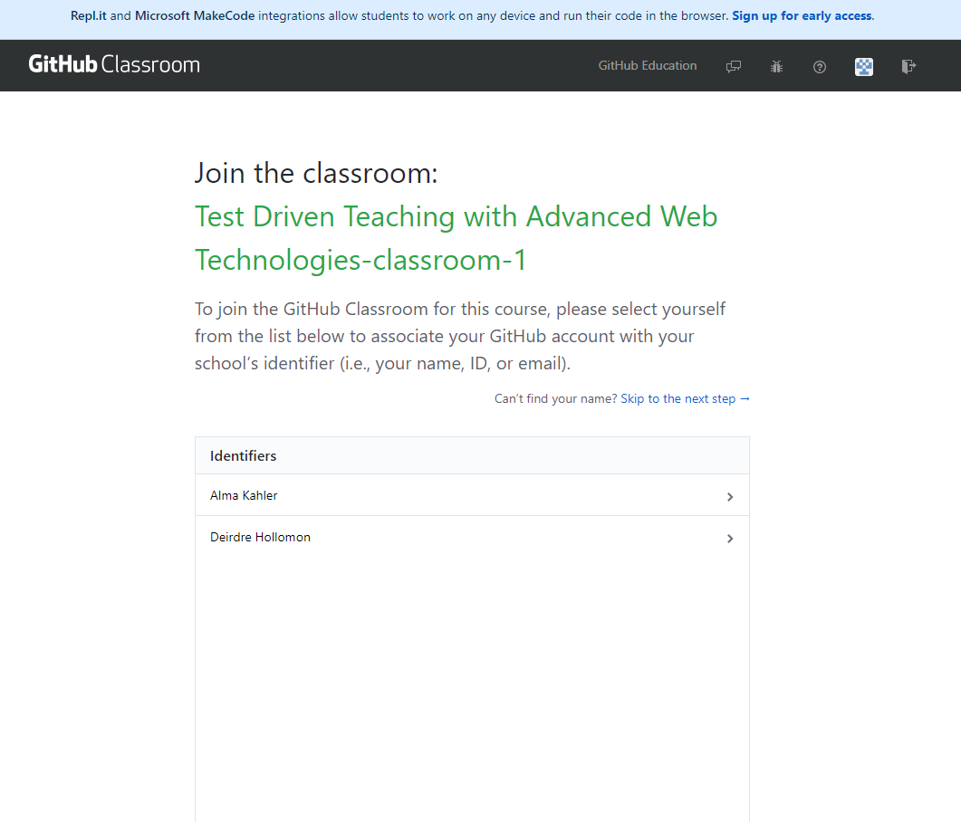

After you have accepted the assignment you should see that Github is setting up a repository for you.
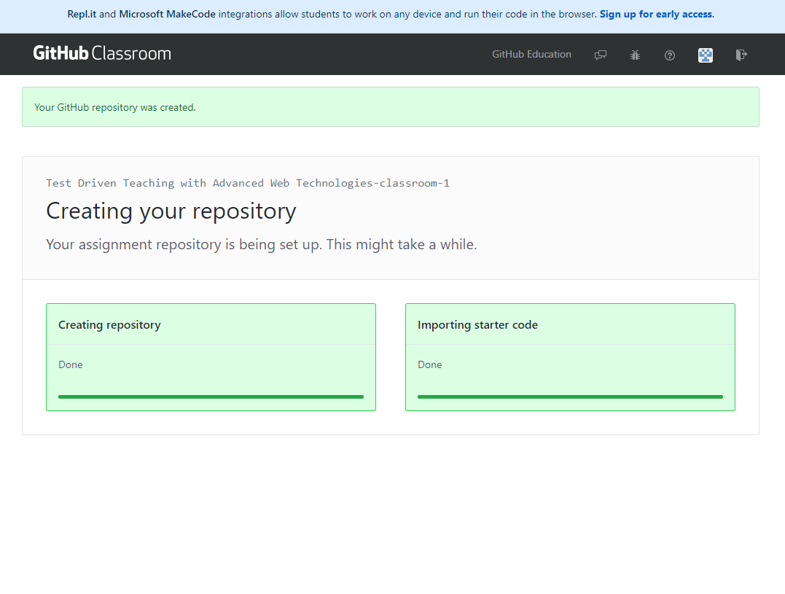
Once it has finished doing so, the page will update with the link to your new repository as shown below:
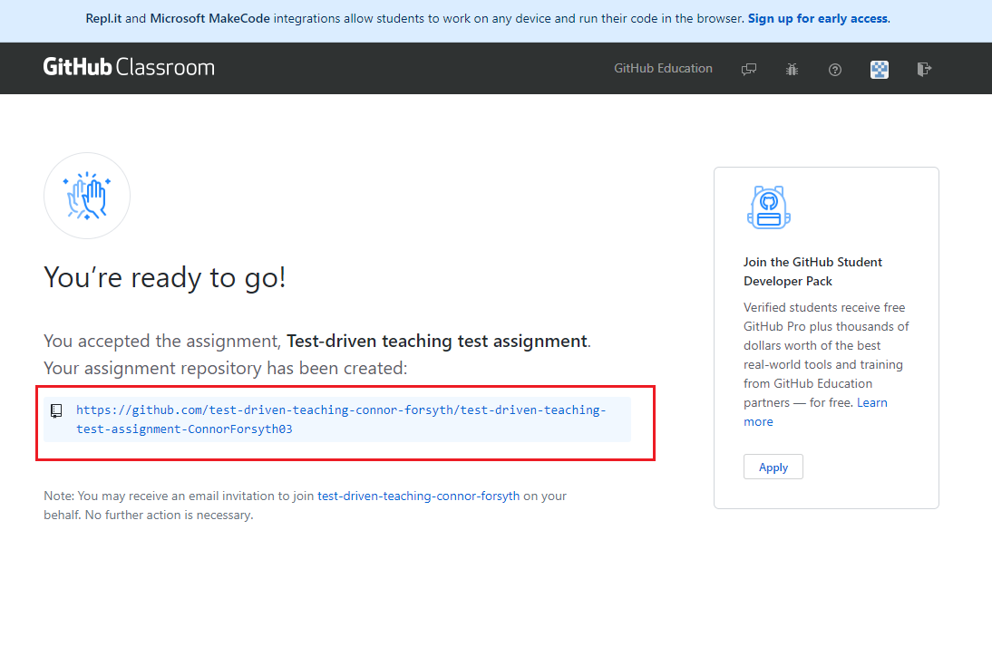

Working on the assignment
You will see that there are various files and folders in your repository. The instructions for the assignment can be found in the Assignment instructions document, feel free to attempt all the questions outlined or one.
Whilst attempting the questions, please use the assignment.js file as the feedback system will be looking at the code in this file to provide you with feedback. Anytime you push changes to this file, your code will be run and compiled and will return with either a pass or fail. To view the output of any work you carry out, please use console.log(YOUR_VARIABLE_HERE); so that you can view what is happening when your code is run and compiled. To view the results of your code, follow the step-by-step process as shown below:
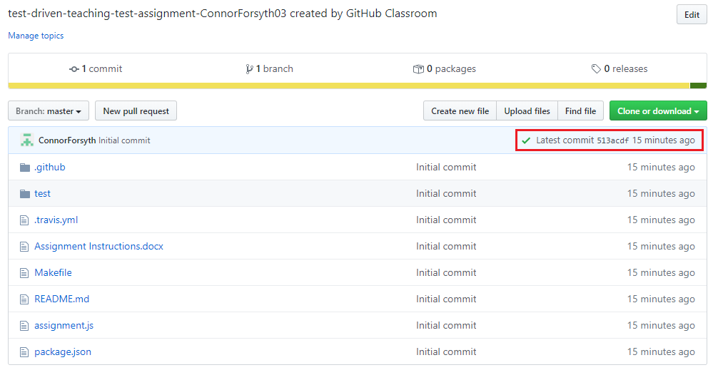
Figure 1 Click on the icon that is highlighted and click the details button the dialog popup

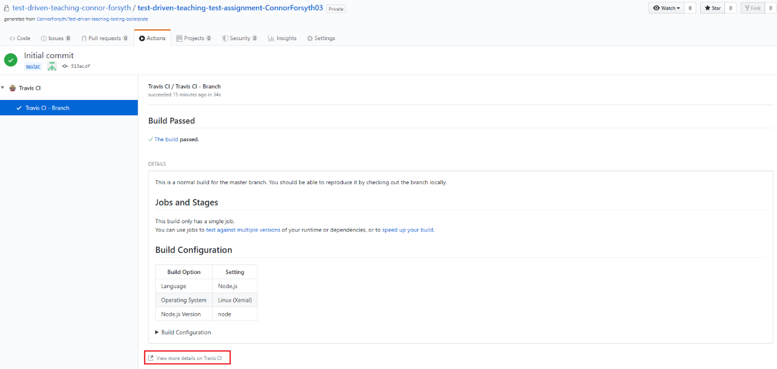
Figure 2 Click view more details
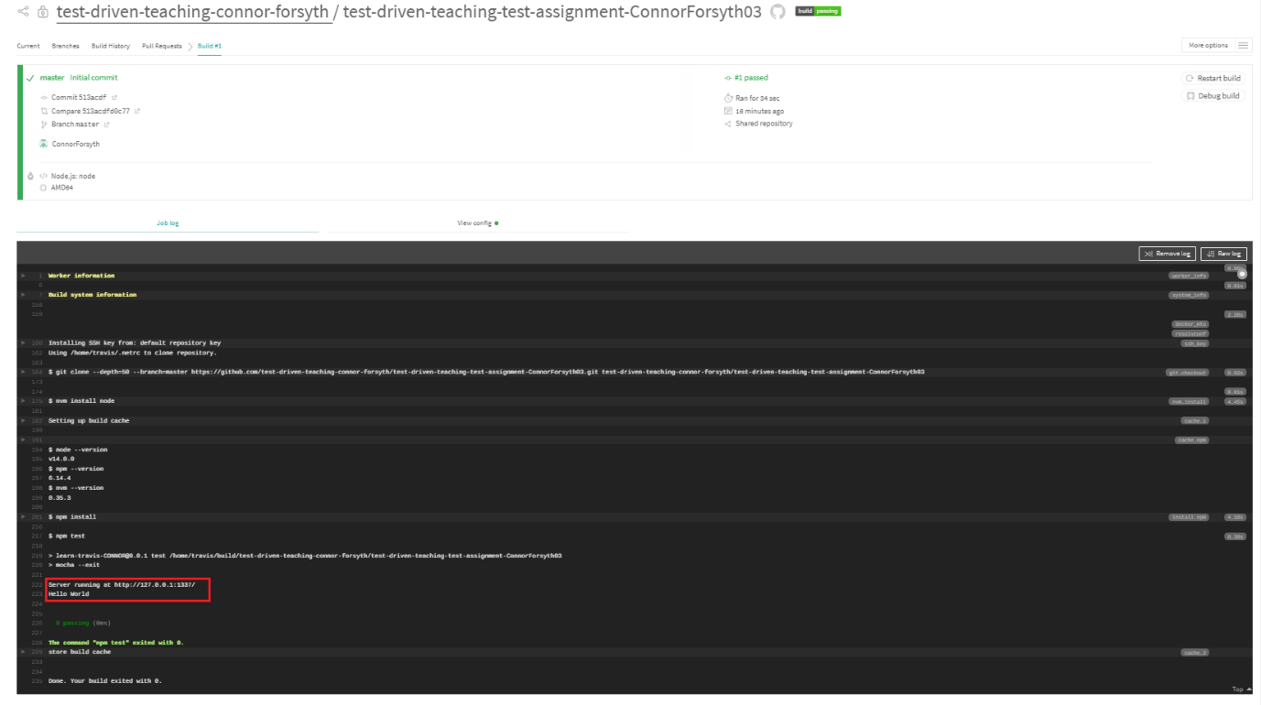
Figure 3 Any output will be displayed below as shown

Asking for help
During your work on the assignment you may come across various errors or issues and you may not be sure what to do so to help alleviate this issue within your repository there are two ways you can ask for help.

The 1st Instance
The 1st of which is contained completely within your repository. Head over to the issues section of your repository and click on the New Issue button. A new page will load that should look like the image below:
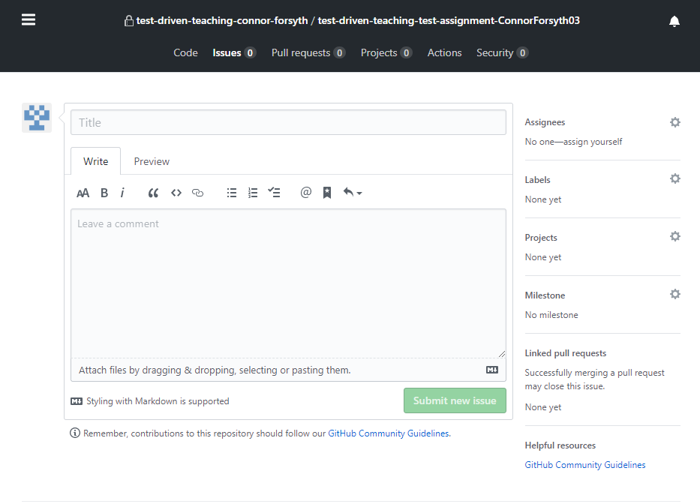
The 1st instance is in fact a bot, enter your question into the title input box that you would like answered and please make sure you select the label ask-the-bot for the bot to see your question as shown below:
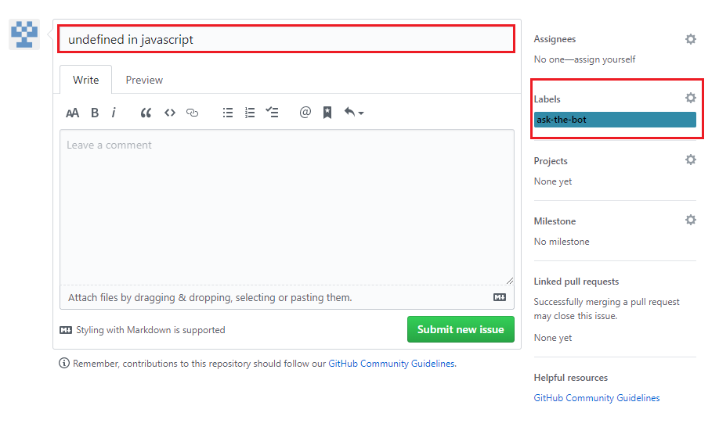
Once you’ve submitted your issue, you should see a response from the bot. If the answer returned is not suitable, you can ask for help from the lecturer by responding to the bot by replying Yes and the lecturer will be notified and should reply as soon as possible.

The 2nd Instance
The 2nd instance will see you ask your fellow students for help. Like the 1st instance, head over to the issues section of your repository and create a new issue. Please enter a brief description of your issue in the title input with a bigger explanation in the description section below. Before you create the new issue, please ensure you have selected the help-wanted label.

Slack
Invite Link: https://join.slack.com/t/rguglobal/shared_invite/zt-e53tlks0-ZVU1n2mibwaGOAcUcIaBag
Whilst this assignment is set as an individual assessment, you may collaborate with one another through Slack. You will notice once you have joined, that there are various channels you can enter. Use the general channel as you please (within reason) and keep an eye on the helpwanted channel the most. The reason for this, is that this is where you will be able to see other student’s requests for help with their code.
